Alzoniella (A.) ovetensis (Rolán, 1993)

height 1.58-2.03 mm, width 1.00-1.24 mm

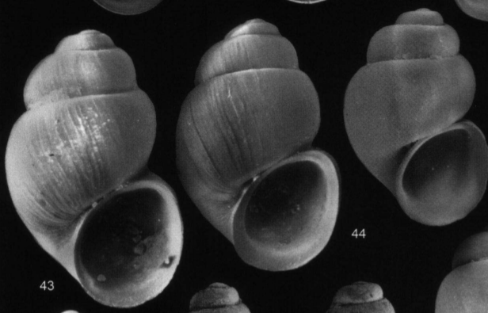

Alzoniella (A.) marianae spec. nov.

height 1.30-1.73 mm, width 0.79-0.93 mm

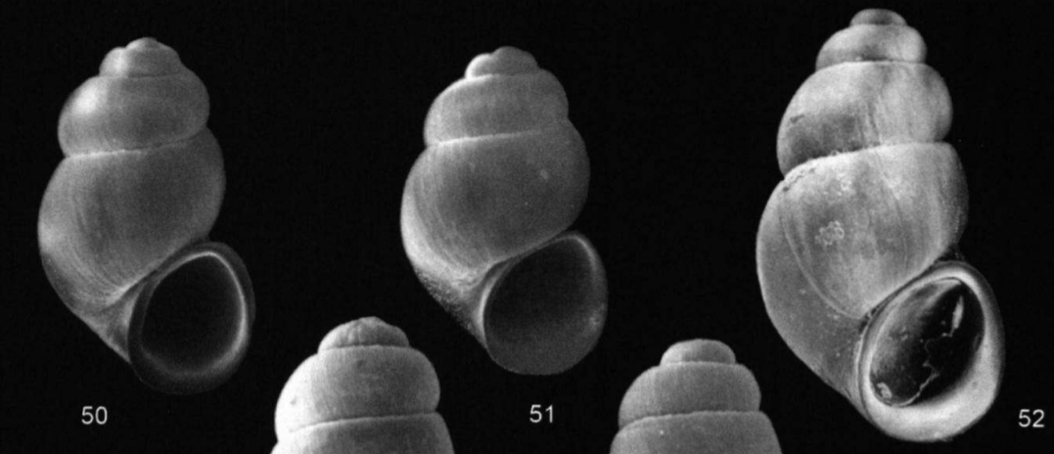

Alzoniella (A.) asturica (Boeters & Rolán, 1988)

1.0-1.1 mm

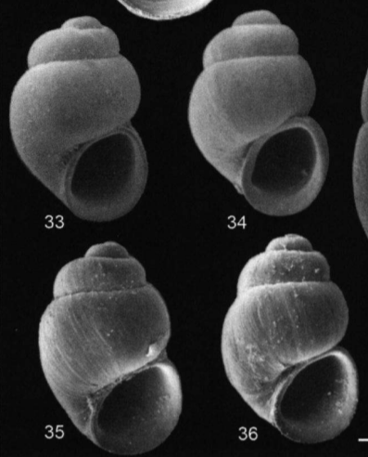

Alzoniella (A.) montana (Rolán, 1993)

1.25-1.37 mm

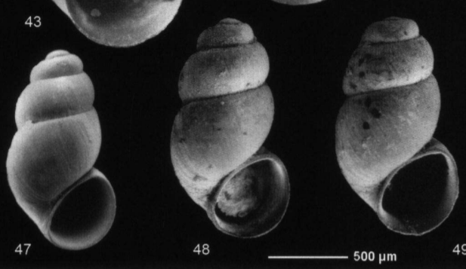

Alzoniella(A.) lucensis (Rolán, 1993)

1.8-2.0 mm

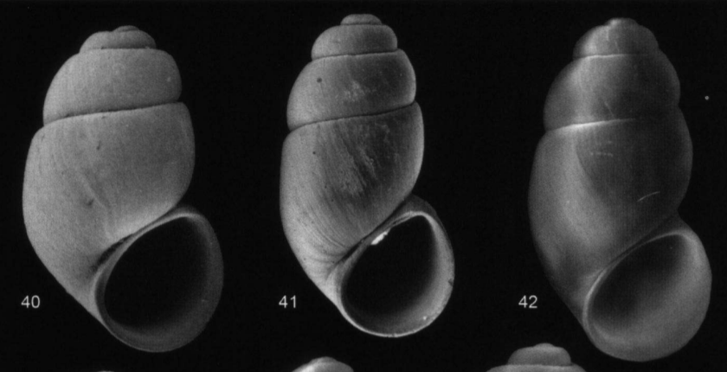

Alzoniella (A.) cantabrica (Boeters, 1983)

Height +- 1.8

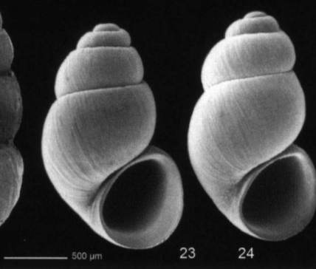

Alzoniella somiedoensis spec. nov. (figs 1-16)

Height 1.35-1.75 [1.54] mm, width 0.90-1.30 [1.07] mm (n = 25).

